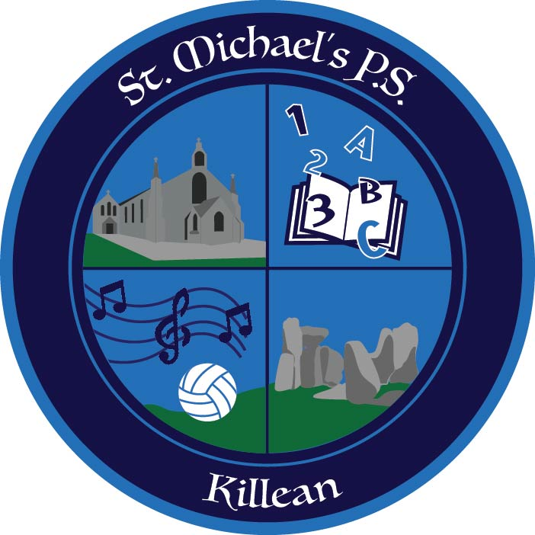

St. Michael’s P.S.
Killean

HEALTH AND SAFETY POLICY

Agreed by Governing Body
Review Date
Review Schedule
Person(s) Responsible | Principal
Signed (Chair of Governing Body)
HEALTH & SAFETY POLICY

1.0 RATIONALE
The Board of Governors objective is to provide and maintain safe and healthy working conditions, so far as is reasonably practicable, for all our staff, pupils and visitors and to encourage a safety culture within the school.

2.0 LEGISLATION
This policy has been written in accordance with:

- The Health and Safety at Work Act (Northern Ireland) Order 1978;

- The Management and Safety at Work Regulations (Northern Ireland) 2000;

- Fire Precautions (Workplace) Regulations (Northern Ireland) 2001;

- The Fire and Rescue Services (Northern Ireland) Order 2006; and

- The Fire Safety Regulations (Northern Ireland) 2010.

3.0 OBJECTIVES
At St. Michael’s Primary School we will endeavour to provide and maintain safe and healthy working conditions so far as is reasonably practicable by:

- ensuring the school has an up to date and relevant Health and Safety Policy;
- ensuring that effective arrangements and adequate resources are allocated to support the Health and Safety Policy and management system;

- actively identifying health and safety hazards and unsafe processes/systems of work with a view to eliminating, controlling or minimising risk where practicable through a recognised assessment process;

- providing suitable and sufficient health and safety information, instruction and training to enable employees to develop and improve their competencies within their working environment in order to carry out their work or activity in a safe and efficient manner;

- engaging and consulting with all employees on providing a safe and healthy working/teaching/learning environment in compliance with, or improving upon statutory requirements;

- actively identifying health and safety hazards; maintaining the cleanliness and state of repair of the building;

- providing safe systems of working to ensure, so far as is reasonably practicable, the health and safety at work of all staff, pupils and visitors;

- managing and maintaining the use of personal protective equipment;

- providing adequate information and training on health and safety at work and fire prevention and ensure that all employees, pupils, contractors, visitors and others follow the appropriate safety procedures;

- providing safe storage for dangerous materials and substances;

- providing adequate first aid provision;

- establishing, practicing and maintaining effective emergency evacuation procedures;

- carrying out detailed reporting and investigation of all accidents and dangerous occurrences to persons and/or property to prevent a recurrence;

- liaising with the Newtownabbey Borough Council, The Education Authority and other official bodies with the aim of improving all aspects of health and safety at work.

All staff, including supply staff and contractors working on the school premises, are required to conduct themselves in a manner in which they pose no risk to their own or any other person's health and safety. 'Other persons' includes staff, pupils, and visitors to the school.

4.0 RESPONSIBILITIES: BOARD of GOVERNORS
The Board of Governors has a statutory responsibility under the Health and Safety at Work
(Northern Ireland) Order 1978 for ensuring that the Education Authority’s Health and Safety Policy is both understood and implemented in schools under their control and that risk assessments are carried out to address significant risks.

The Scheme of Management and the Common Funding Scheme for the Local Management of Schools also places responsibility on the Board of Governors for a number of functions and duties in respect of health and safety. The Chairperson is the Designated Governor for Health & Safety.

The Board of Governors is responsible for:

- ensuring that the Principal and School Leadership Team develop a safety management system throughout the school which should include an appropriate health and safety policy;

- monitoring the effectiveness of the school’s health and safety arrangements;

- ensuring that the Principal and School Leadership Team have procedures for the safety of all persons using the premises under their control;

- ensuring that the Principal and School Leadership Team have arrangements in place for the prompt and efficient maintenance of all non-structural repairs and equipment;

- having appropriate delegated arrangements in place with the Principal to ensure that contractors who are carrying out work on behalf of the Board of Governors undertake the work in a safe manner.

- The Board of Governors recognises that achieving and maintaining high standards of safety requires them to ensure that the school's management, staff, pupils, visitors and contractors are aware of and discharge their respective responsibilities.

- The Principal is the school’s Health and Safety co-ordinator and is responsible for instigating an investigation and, where appropriate, authorising remedial work or action and reporting to the Board of Governors.

5.0 RESPONSIBILITIES: PRINCIPAL (Health and Safety Co-ordinator) The Principal supported by the school’s building supervisor is responsible for the day-to-day implementation of the school's Health and Safety Policy.

The Principal is responsible for:

- liaising with the school’s building supervisor regarding health and safety matters;

- developing and implementing an effective safety management system for the school, which should include an appropriate Health and Safety Policy;

- ensuring that health and safety forms an integral part of subject planning within the school;

- ensuring the availability of resources to maintain and improve the safety management arrangements; ensuring that all employees have appropriate experience and training to safely undertake their work and to continually develop and improve their competencies in order to carry out their work or activity in a safe and efficient manner;

- monitoring the safety performance throughout the school during Senior Leadership Team meetings;

- ensuring that equipment and materials purchased by the school are safe and suitable for their intended use;

- developing arrangements for ensuring effective maintenance of a safe working environment;

- developing and implementing arrangements to ensure that prompt and efficient maintenance is carried out on all non-structural repairs and all equipment;

- initiating a risk assessment process where there is a significant risk to health and safety, and communicating the results of those assessments to employees and other persons likely to be affected by the activity or process;
maintenance of procedures for the safety of all persons using the premises under their control;

- appropriate fire and emergency procedures are established;

- liaising with building contractors and ensuring procedures are in place to ensure that all contractors are presented with the school’s asbestos register prior to any work or inspections are being carried out on the premises (in St. Michael’s Primary School this responsibility has been delegated to the Building Supervisor);

- ensuring that Portable Appliance Testing (PAT) is carried out in line with PAT guidelines;

- The school’s fire alarm system is maintained;

- Ensuring that both teaching and non-teaching staff are issued with a copy of the school’s Health and Safety Policy.

- Monitoring the effectiveness of the school’s Health and Safety Policy.

In the absence of the Principal, the Senior Teacher will deputise.

6.0 RESPONSIBILITIES: TEACHING STAFF
Each member of the teaching staff has a responsibility to exercise care and attention regarding the safety of themselves and pupils under their control.

Each teacher is responsible for:
- carrying out risk assessments where there is a significant risk to health and safety and integrating the results into teaching practice;

- ensuring that health and safety forms an integral part of subject planning within their teaching practice;

- taking reasonable care not to endanger their own health and safety and that of other persons likely to be affected by their acts or omissions;

- carrying out and teaching safe working during class lessons;

- undertaking their tasks as instructed and in line with any training received;

- ensuring that all protective clothing and equipment as required is both available and used by themselves and pupils;

- reporting hazards or health and safety concerns to the Principal or building supervisor;

- reporting to the Principal all accidents involving injury, damage to plant and equipment, or potential injury, damage or loss and as appropriate ensuring that Accident Forms are fully completed;

- not interfering with or misusing any equipment provided to ensure safe working practice in the workplace;
co-operating fully with the Principal on all matters pertaining to health and safety.

7.0 RESPONSIBILITIES: ALL STAFF
Each member of staff has a responsibility to exercise care and attention regarding the safety of themselves and others.

Each member of staff is responsible for:

- taking reasonable care not to endanger their own health and safety and that of other persons likely to be affected by their acts or omissions;

- undertaking their tasks as instructed and in line with any training received;

- reporting hazards or health and safety concerns to the Principal or building supervisor;

- reporting to the Principal all accidents involving injury, damage to plant and equipment, or potential injury, damage or loss and as appropriate ensuring that Accident Forms are fully completed;

- not interfering with or misusing any equipment provided to ensure safe working practice in the workplace;

- co-operating fully with the Principal on all matters pertaining to health and safety.

8.0 FIRE SAFETY AND EMERGENCY EVACUATION
In meeting the duties contained in the Fire Precautions (Workplace) Regulations (Northern Ireland) 2001, the Education Authority ensures that a fire risk assessment for all its premises is carried out (by a suitably qualified person) recorded and takes account of the requirements of The Fire and Rescue Services (Northern Ireland) Order 2006 introduced and supported by; The Fire Safety Regulations (Northern Ireland) 2010.

The Board or school management as appropriate will implement recommendations arising from the fire risk assessment.
Fire Marshalls/Wardens are appointed to ensure that all employees are aware of the fire evacuation policy and procedure and that all occupants are evacuated from the building in an emergency.
The school’s fire alarm system should be inspected and maintained at suitable intervals by qualified persons.

9.0 RISK ASSESSMENT
To comply with the Management of Health and Safety Regulations (Northern Ireland) 2000, the Education Authority is required to make a suitable and sufficient assessment of the risks to the health and safety of its employees to which they are exposed whilst they are at work and the risks to the health and safety of persons not in its employment arising out of or in connection with the conduct of its undertakings.

Risk assessments are undertaken by the school Principal or a designated representative in consultation with affected employees. Where the risk is considered significant, this is recorded and appropriate controls put in place.

Controls are monitored regularly by the Principal or a designated representative and reviewed as necessary.

A risk assessment should be undertaken where a new activity or new equipment is introduced. Employees should be informed by the Principal or a designated representative of any risks involved in their daily work activities and of the safe system of work in place to mitigate, so far as is reasonably practicable, the risk of injury.

10.0 AREAS OF SPECIAL RISKS
The school will follow any guidance issued by the Education Authority in relation to the use of equipment or substances or the performance of activities recognised as being of special risk. The need for training in the use of equipment perceived to constitute a risk and the need for regular servicing and maintenance is acknowledged.

The school has an agreed Asbestos Management Policy and Plan which must be followed to ensure the safety of all children and adults on the school premises.

11.0 HEALTH PROBLEMS / ACCIDENTS
Emergency contact names and numbers are requested for all pupils and staff. Pupil and staff health problems, e.g. diabetes, asthma etc. are also recorded. In the event of serious illness an ambulance will be called, parents/carers or next of kin will also be contacted.

12.0 SCHOOL VISITS AND ‘OFF SITE’ ACTIVITIES
The Board of Governors will comply with the guidance the Education Authority has issued on school visits and ‘off site’ activities.

The Principal will submit to the Board of Governors as appropriate, a report on the arrangements for the management of health and safety, and welfare of pupils on all or certain types of off-site activities prior to the activities taking place.

Reports will detail:
- the transport arrangements; the arrangements for supervision of pupils (including the staff/adult: pupil ratio);
- the arrangement for first aid cover;
- the level of qualified instruction and supervision that will be available for activities of special risk.

13.0 FIRST AID PROVISION (see Policy)
The Principal will ensure, through the risk assessment process that adequate provisions are made to administer first aid for any injuries sustained by employees or pupils whilst in school. Where it is assessed as being necessary, competent persons will be appropriately trained and supported to carry out their roles in accordance with the duties in the Health and Safety (First Aid) Regulations (Northern Ireland) 1982. Names and locations of the school’s specific first aiders will be prominently displayed in the workplace.

The school’s First Aid box is stored in the staffroom and main office.

14.0 INSTRUCTION AND TRAINING
The school is committed to providing instruction and training for all employees on safeworking practices and procedures. The school will ensure, through its internal and external training programmes, that all employees have the appropriate level of competence to be able to safely carry out their roles.

The Principal must ensure that all new employees receive induction training and that all employees are competently trained in the safe use of any equipment that they may use during the course of their employment.

All employees will receive refresher training and any further training necessary as a result of changes in the workplace arising from the introduction of new procedures or new equipment.

15.0 WORKING ENVIRONMENT
The Principal will monitor the general working environment as required. This will include the monitoring of noise, lighting, ventilation, fumes and dust levels. Any problems in these areas will be reported to the appropriate section for measurement and the implementation of remedial measures if necessary.

16.0 ACCIDENTS AND INCIDENTS
The Board of Governors and the Principal will monitor all accidents and incidents and implement the necessary control measures to prevent any recurrence.

All accidents and incidents must be recorded in line with the Education Authority’s accident reporting policy. The Principal will undertake initial investigations. Where required the Principal will report any accidents or incidents to the Education Authority.

17.0 HEALTH AND SAFETY INSPECTIONS (PROACTIVE MONITORING) To improve health and safety performance and to assist in promoting a positive health and safety culture, the Board of Governors will ensure that health and safety inspections are carried out on a regular basis. It is their responsibility to take steps or make recommendations to eliminate unsafe acts, and unsafe conditions and take immediate corrective action to prevent recurrence. Health and safety inspections, associated actions, recommendations, responsibilities and timescales should be recorded.

18.0 REPORTING, MONITORING AND REVIEWING SAFETY
To ensure this policy remains relevant and appropriate to the school, it will be reviewed every three years or more frequently should the need arise, e.g. on the publication of new regulations or on the receipt of new documentation from the Education Authority.

